1) SYSTEM CONTEXT-LEVEL DIAGRAM

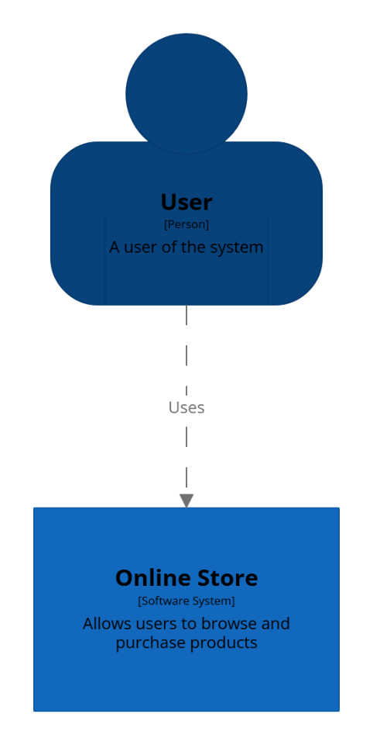

LEGEND


2) SYSTEM CONTAINER-LEVEL DIAGRAM
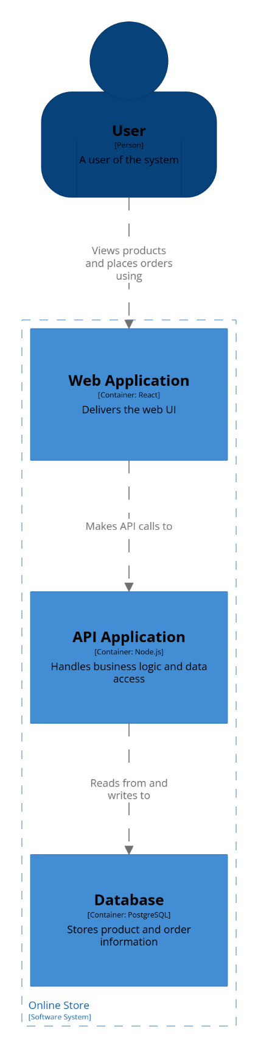

LEGEND
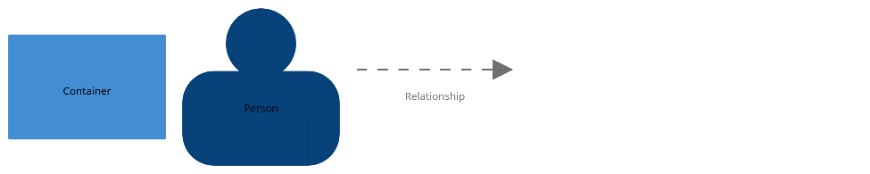
3) SYSTEM COMPONENT-LEVEL DIAGRAMS
API Application Component: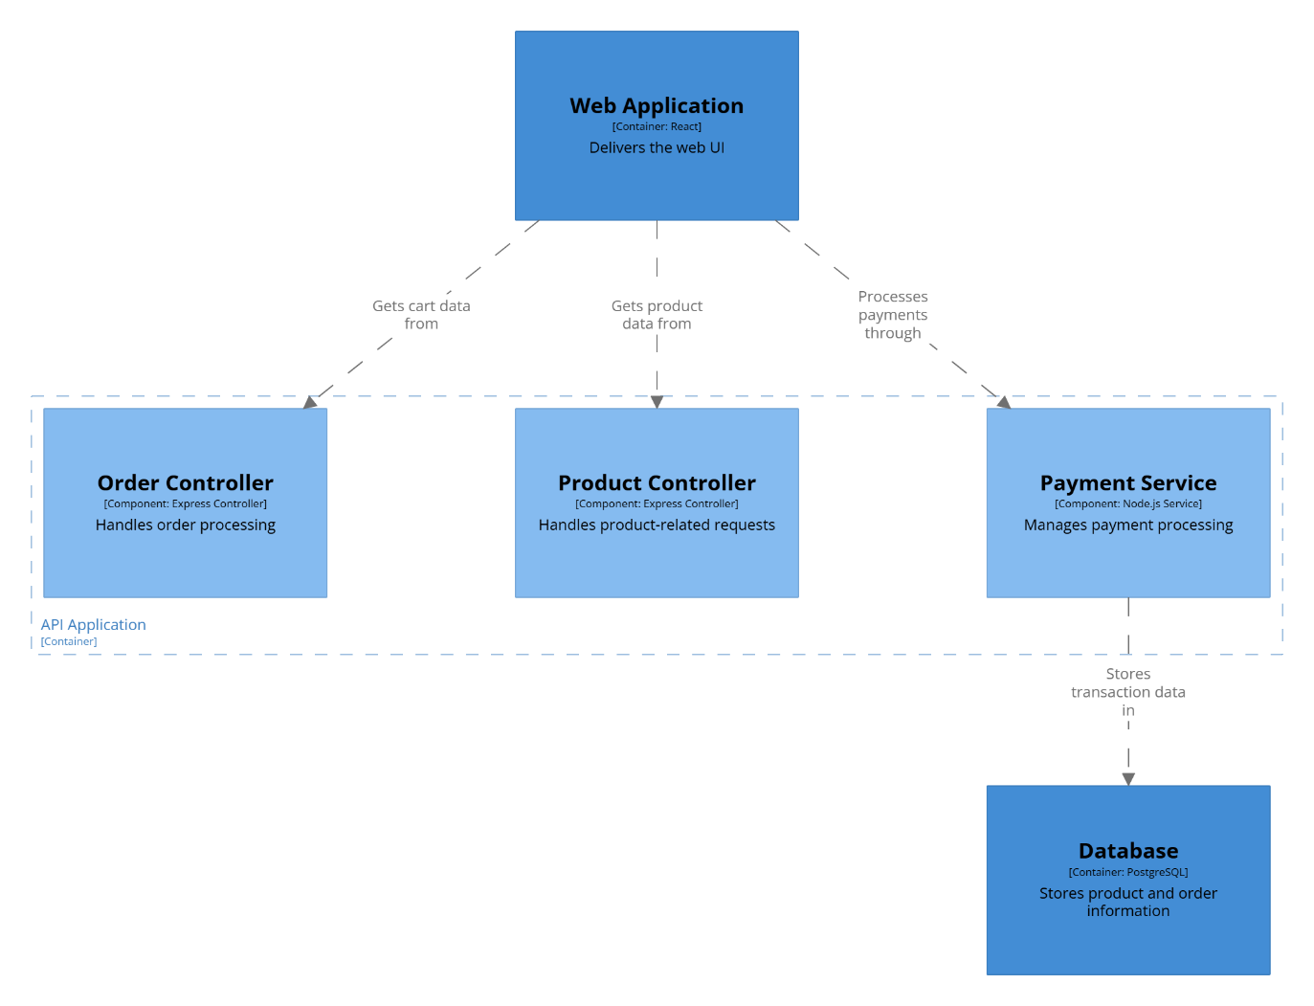
Web Application Component: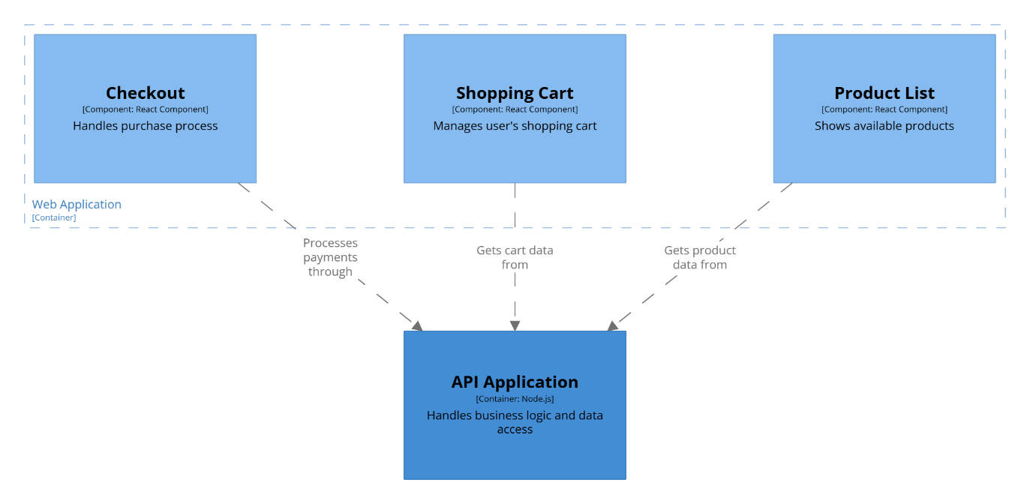

LEGEND
